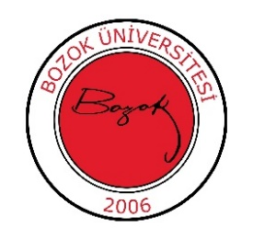
T.C.
YOZGAT BOZOK UNIVERSITY
Faculty of Arts and Sciences
Department of Archaeology

2024-2025 Academic Year Spring Semester
Make-up Examination Schedule

Course Code and Name | Exam Date | Exam Time | Classroom | Responsible Instructor
TDI002 Turkish Language II | 26.06.2025 Thursday | 10:00-11:45 |  | Lect. Mehmet Ali KİRAZ
YDL002 Foreign Language II (English) | 26.06.2025 Thursday | 10:00-11:45 |  | Lect. M. Cihat BASATOĞRUL
ATA002 Atatürk's Principles and History of Revolution II | 26.06.2025 Thursday | 10:00-11:45 |  | Lect. Döndü Sena GÖNDÜRÜ, PhD
ADSL-013 Mythology and Iconography in Ancient Near Eastern-1 | 26.06.2025 Thursday | 09:00-09:45 |  | Assoc. Prof. Serkan ERDOĞAN
ARK124 Archaic Sculpture | 25.06.2025 Wednesday | 10:00 | B-102 | Asst. Prof. Özge ALTUN
ARK125 Mythology | 25.06.2025 Wednesday | 11:00 | B-102 | Assoc. Prof. Hacer SANCAKTAR
ARK123 Introduction to Pottery | 25.06.2025 Wednesday | 13:00 | B-102 | Asst. Prof. Özge ALTUN
KAR001 Career Planning | 27.06.2025  Friday | 11:00 | B-102 | Asst. Prof. Savaş ALTUN
ARK121 Prehistory of Türkiye | 27.06.2025 Thursday | 13:00 | B-102 | Assoc. Prof. Serkan ERDOĞAN
ARK122 History of Near Eastern Culture I | 27.06.2025  Friday | 14:00 | B-102 | Asst. Prof. Savaş ALTUN

