ACTIVITIES
- Career Days Activities
As part of the Career Days, a talk and hands-on activity entitled "Terrarium Making" and "Rose Pruning and Cutting Propagation" was conducted by our Faculty academics Assoc. Prof. Dr. Kübra YAZİCİ and Res. Asst. Selin TEMİZEL. Academic staff and students participated in the activity, which was held in the Faculty building and garden. Information was provided on the first use of terrariums in history and their purposes of use, followed by general information on the succulents and cacti used in terrariums and an explanation of the construction process. In addition, the general purpose of pruning was discussed in the Faculty garden. Three different rose-pruning methods were explained, together with the points to be considered when taking cuttings. At the end of the Career Days activities, our Department academic staff members Assoc. Prof. Dr. Kübra YAZİCİ and Res. Asst. Selin TEMİZEL were presented with certificates of appreciation by the Dean’s Office.
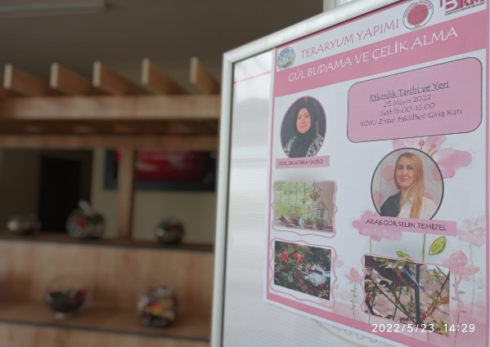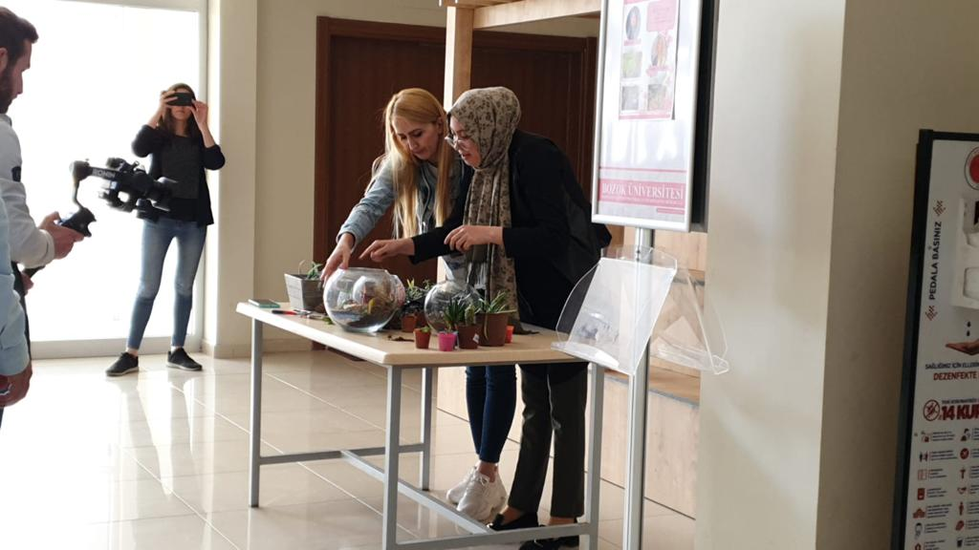
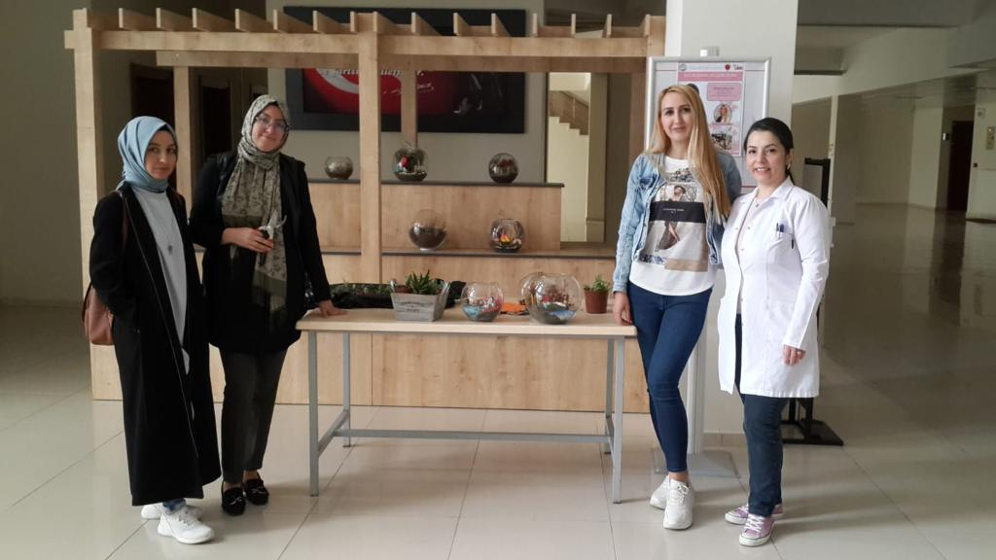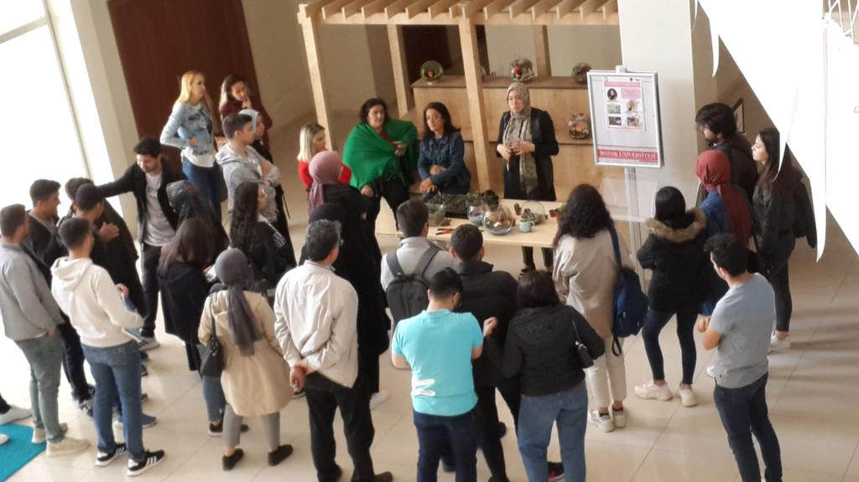
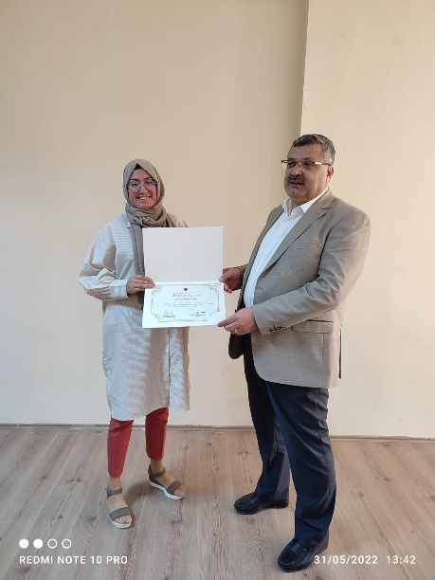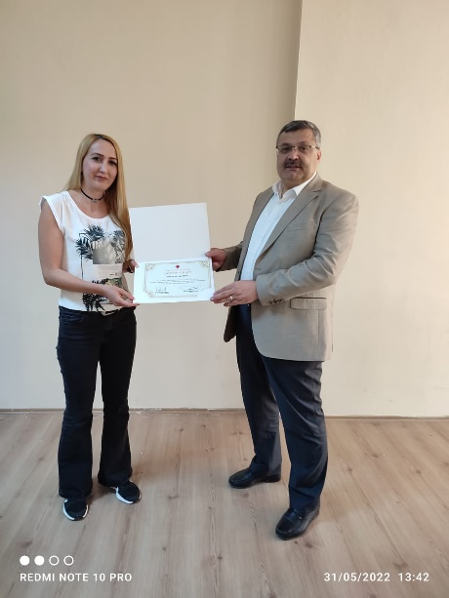

- Honorable Mention Award
At the 1st R&D Project Market, organized under the leadership of the Anatolian Universities Union and supported by TÜBİTAK, the Scientific and Technological Research Council of Türkiye, the evaluation conducted by the Organizing Committee resulted in Assoc. Prof. Dr. Kübra YAZİCİ, Head of the Department of Landscape Architecture at our Faculty, being awarded an Honorable Mention in the AGRICULTURE, FOOD AND ENVIRONMENTAL SCIENCES category for the project entitled “Smart Campuses as a Legacy for Future Generations: The Case of Yozgat Bozok University.”
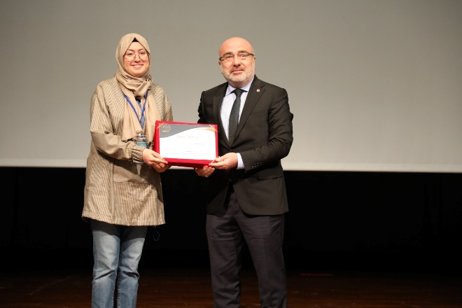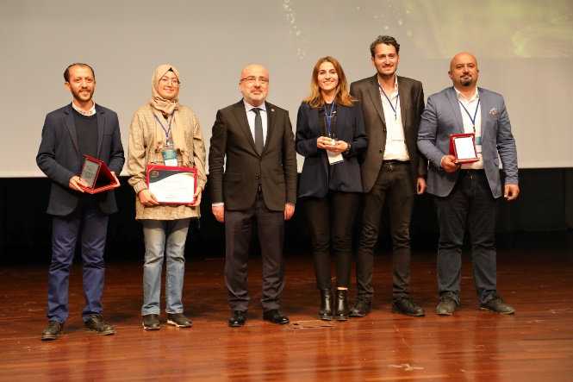
- Master’s Seminar
On 7 June 2022, Melek KAPLAN, a master’s student in the Department of Agricultural Sciences under the supervision of Assoc. Prof. Dr. Kübra YAZİCİ, presented the seminar entitled “Historical Landscape Value of Campus Areas: The Case of Yozgat Bozok University.”
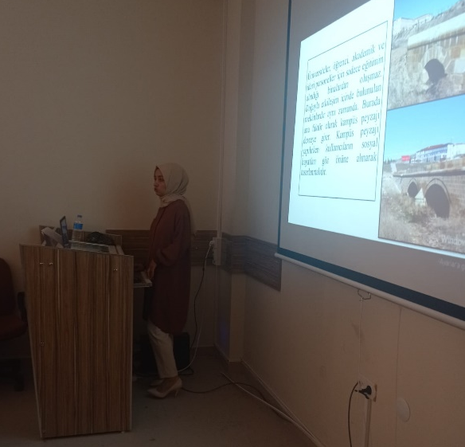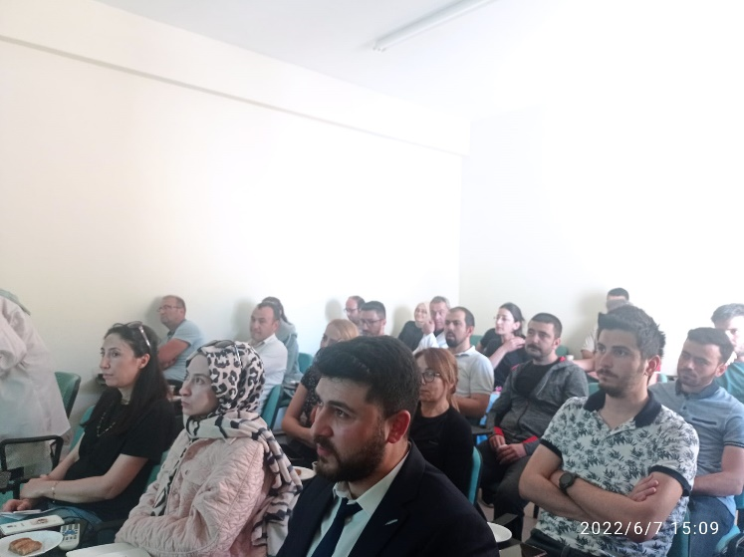

- Sapling Planting Activity at Our Faculty
Academics of the Department of Landscape Architecture, Assoc. Prof. Dr. Kübra YAZİCİ and Res. Asst. Selin TEMİZEL, participated in a sapling planting activity together with administrative staff and students.

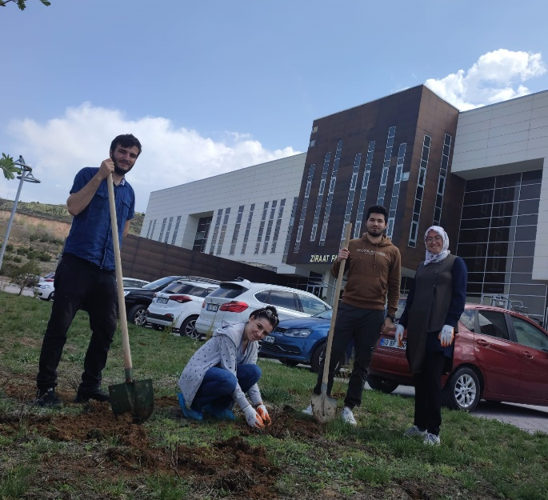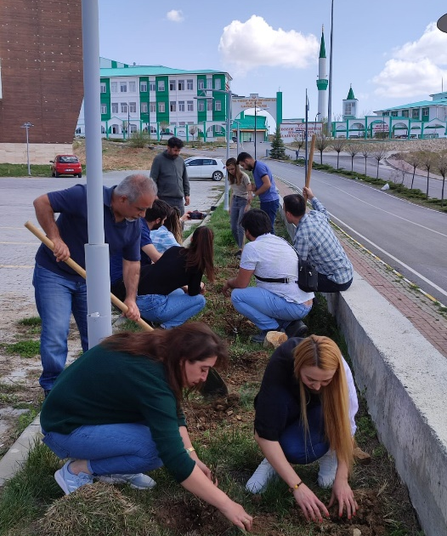
- Editorship-in-Chief of the Bozok Journal of Agriculture and Natural Sciences
Assoc. Prof. Dr. Kübra YAZİCİ, a faculty member of the Department of Landscape Architecture, was appointed Editor-in-Chief of the Bozok Journal of Agriculture and Natural Sciences. The logo of the Bozok Journal of Agriculture and Natural Sciences was designed by Atakan PİRLİ under the leadership of our Department faculty member Assoc. Prof. Dr. Kübra YAZİCİ.
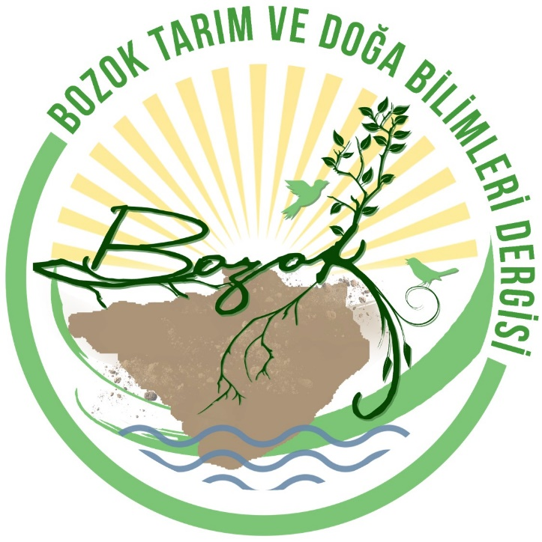

- Academic Incentive Achievements
Assoc. Prof. Dr. Kübra YAZİCİ, a faculty member of Landscape Architecture in the Faculty of Agriculture, ranked 3rd university-wide in the academic incentive score ranking. Res. Asst. Selin TEMİZEL of the Department of Landscape Architecture received an academic incentive award.

- 8 March International Women’s Day and Lavender Planting
Our Rector, Prof. Dr. Ahmet Karadağ, and our Vice Rectors presented carnations on the occasion of International Women’s Day to the women participating in the program, as well as to female healthcare professionals working at our University Research and Application Hospital and to members of the public. Our Rector, Prof. Dr. Ahmet Karadağ, celebrated 8 March International Women’s Day by expressing his wish for a world free from violence against women. Following the program, academics from the Department of Landscape Architecture, Assoc. Prof. Dr. Kübra YAZİCİ and Res. Asst. Selin TEMİZEL, participated in the planting of lavender in the Tenzile Erdoğan Memorial Forest located on our University campus.

- Faculty of Agriculture Landscape Project Designed by Our Academic Staff Member
During the preparation of the Faculty of Agriculture Landscape Project, whose design and drawings were produced by Res. Asst. Selin Temizel of the Department of Landscape Architecture, a site inventory study was first carried out at the design stage. Two vehicular entrances were designed for the Faculty grounds. At the upper vehicular entrance, Magnolia grandiflora (southern magnolia) was selected as a solitary specimen in the center. An ornamental pool was preferred in the central area for visual purposes, with seating units arranged around it. An effort was made to provide sufficient seating units in the central area. A parking area with a capacity of approximately 150 vehicles was designed. In the landscaped area of our Faculty, where the sunset offers a magnificent view, an amphitheater with a capacity of approximately 80 people was designed toward the upper part of the slope. The amphitheater, where students can gather and organize activities in their free time, is also a particularly pleasant area from which to enjoy the beautiful view due to its location. For a high-quality, homogeneous, green appearance in lawn areas, Festuca arundinacea, a cool-season turfgrass species suitable for the city of Yozgat, was selected.
- Book Publication
The book entitled “Fundamental Building Blocks of Landscape” by Assoc. Prof. Dr. Kübra YAZİCİ, Head of the Department of Landscape Architecture, has been published.
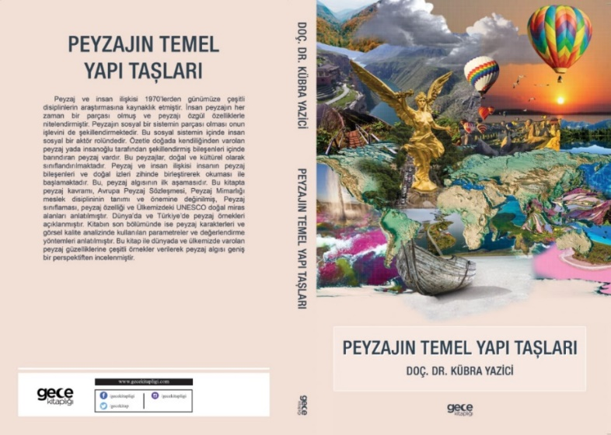
- I Design My Pot Activity
Potted indoor or balcony plants have recently assumed an important place in our lives. With the slogan “Life Fits into Home,” during the struggle against the pandemic, our homes became, for us, a restaurant, a gym, a café, a cinema, a place where we acquired new hobbies, or a school where we continued our education. Within concrete structures, one of our greatest deficiencies is our distance from nature. Plants, one of the fundamental components of nature, are also important elements that help alleviate our longing for nature in our homes. In addition to their functional characteristics, potted indoor or balcony plants used in homes and offices also have psychological effects. Our students attend the “Flower Care and Cultivation” course from their homes. Within the scope of this course, this activity was organized during the COVID-19 pandemic in order to make our online classes more comprehensible, to create an opportunity for our students to get to know one another since they did not have such an opportunity as in face-to-face education, to see the plants they enjoy growing at home, and to increase awareness of the course. Within the scope of the non-departmental course “Flower Care and Cultivation,” for which Assoc. Prof. Dr. Kübra YAZİCİ is the course instructor, the activities “I Design My Own Pot” and “A Corner from Our Home” were organized with students in order to conduct the course efficiently and effectively during the pandemic. We thank our students who participated online in the course and the activity for their efforts.
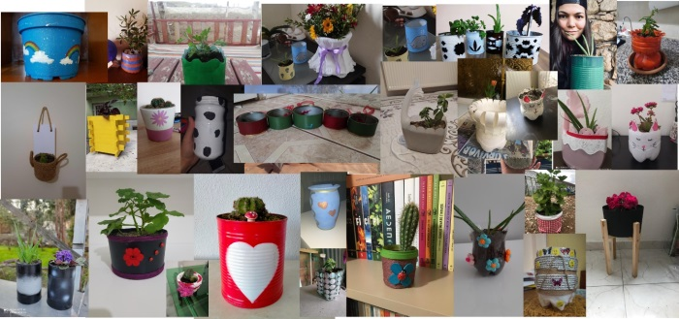
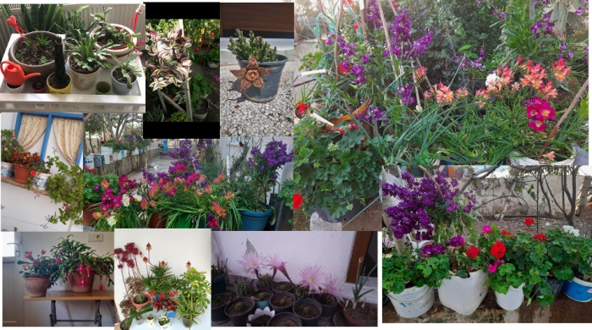

- Recreation Area Landscape Project
Res. Asst. Selin TEMİZEL, an academic staff member of our Department assigned by the Rectorate of Yozgat Bozok University, designed a landscape project for the recreation area belonging to the Ahmet Şevki Ergin Culture and Service Foundation (AŞK).
Please click the link below to access the source of the news.
http://www.yozgat.gov.tr/ahmet-efendi-hayratlarla-yasatiliyor

