**GENERAL INSTRUCTIONS FOR LABORATORY WORK**
**1. PURPOSE:**
The purpose of this instruction is to ensure that all laboratory activities and work involving work equipment at Yozgat Bozok University campuses are carried out in a manner that does not endanger the health and safety of employees or those around them, and to define the precautions to be taken against potential hazards and risks.
**2. SCOPE:**
This instruction covers the use of laboratories by personnel and students working in laboratories at Yozgat Bozok University campuses, as well as their responsibilities and safety precautions.
**3. LEGAL BASIS:**
This instruction has been prepared in accordance with the Occupational Health and Safety Law No. 6331, Labor Law No. 4857, Social Insurance and Universal Health Insurance Law No. 5510, and Turkish Penal Code No. 5237, together with the relevant secondary legislation issued pursuant to these laws.
**4. RESPONSIBILITIES:**
The heads of relevant units and all students and personnel working in the laboratories at Yozgat Bozok University campuses are responsible for implementing this instruction.
**5. IMPLEMENTATION:**
### GENERAL SAFETY RULES FOR LABORATORY WORK
Before starting work, **always read the General Safety Rules for Laboratory Work.**
* **Do not work alone in the laboratory.** For work conducted outside normal working hours, comply with the applicable authorization procedures.
* Read the operating and safety instructions for the machinery, equipment, and processes being used in the laboratory. Sign any rules and instructions for which acknowledgement is required.
* Comply with the instructions indicated by the health and safety signs displayed in the laboratory.
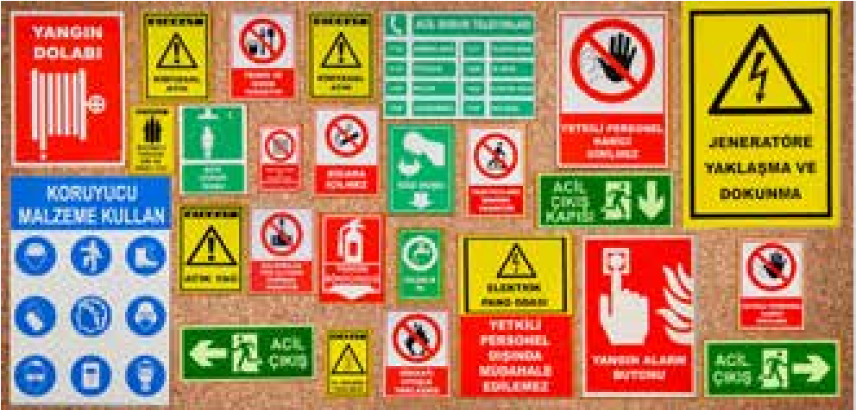
* Follow the written and verbal instructions of laboratory supervisors and authorized personnel.
* Use the designated walkways within the laboratory.
* Access points to and from the laboratory shall be controlled, and persons other than authorized personnel shall be prevented from entering areas where analyses are being conducted.
* Do not behave in a manner that may disrupt order or create a hazard in the laboratory. **Horseplay is strictly prohibited in the laboratory.**
* Do not keep personal belongings such as bags, wallets, coats, cardigans, or jackets in the laboratory work area.
* Do not eat or drink anything in the laboratory. Do not touch your face while working, and do not ingest any substance orally.
* Do not use laboratory equipment or materials for purposes other than those for which they are intended.
* Dress appropriately for laboratory working conditions. If you have long hair, tie it back. Do not work with loose jewelry or loose-fitting/hanging clothing. Do not enter the laboratory wearing footwear that is unsuitable for laboratory conditions, such as open-toe shoes.
**Do not wear contact lenses while working in the laboratory.**
•Laboratuvara gelmeden önce tedavi amaçlı ilaç alınması halinde, laboratuvar sorumlusuna bilgi veriniz.
* If you have any cuts, wounds, or similar injuries on your hands, cover them with a waterproof bandage before continuing to work.
* Do not listen to music in the laboratory.
* Do not work in the laboratory without using the required **Personal Protective Equipment (PPE)**. The appropriate PPE may vary depending on the work area. Always use the PPE suitable for the task.
* Clean your PPE after use and store it in the designated storage container.

* Ensure that the lighting conditions in the laboratory are appropriate for the work being performed.
* Arrange the laboratory work area in accordance with the work being carried out.
* Make sure that the work area is spacious enough to allow you to move comfortably.
* Dispose of waste generated during your work in the designated waste containers in accordance with the relevant instructions.
* **Do not pour chemicals down the sink.**
* Obtain the **Safety Data Sheets (SDSs)** for the chemicals used in your laboratory from the supplier.
* Label, use, store, and dispose of chemicals with reference to the information provided in their SDSs.
* When pouring liquids from chemical bottles, hold the bottle with the label facing upward.
* Do not mix chemicals indiscriminately.
* Store chemicals according to their hazard classifications and storage requirements in separate rooms, cabinets, or storage areas equipped with appropriate ventilation systems. Areas where chemicals are stored shall be kept locked, and the key shall be held by the laboratory supervisor.
* Keep only the amount of chemicals required for the work in the laboratory work area.
* Exercise caution and ensure your safety when transporting chemicals within the laboratory. Use both hands when carrying chemicals: hold the cap firmly with one hand and support the bottom of the bottle with the other.
* If it is necessary to transport chemicals, biological materials, or samples from one laboratory to another, use a secure and sturdy basket, hand trolley, or similar suitable equipment.
* In the event of a chemical spill, refer to the information provided in the relevant **Safety Data Sheet (SDS)**. If chemical absorbent pads or sand are used, the materials used shall be treated and disposed of as chemical waste after the cleanup has been completed.
* Label all containers containing chemicals. If an unlabeled container is found, inform the laboratory supervisor and **do not touch the container**.
* Do not smell chemicals, taste them, or allow them to come into contact with your skin.
* When transferring chemicals from bottles, **never pipette by mouth**. Use a vacuum device or pipette filler.
* Handle glassware with care. When dealing with broken glass and cleaning up glass fragments, use special protective gloves or a suitable cloth to prevent cuts to your hands.
* If mercury is spilled in any way, collect it using a vacuum source or foam-type synthetic sponges. If only a trace amount is spilled and cannot be collected, sprinkle powdered sulfur over it. **Never dispose of mercury-containing parts of broken thermometers or mercury residues in regular waste bins or down the sink.** Package them appropriately and dispose of them in the designated waste container in accordance with the waste management procedures.
* **Do not interfere with electrical panels**, and do not allow unauthorized persons to do so.
* Do not unplug electrical plugs by pulling on the cord. When working with electricity, ensure that your hands and the surfaces you are standing on are dry and non-metallic.
* If you use a **portable electrical cable** in the laboratory, do not connect multiple portable cables together.
* The **Emergency Response Team List** document contains the contact numbers of the persons and organizations to be contacted in the event of an emergency. Keep the team list on the exit route inside each laboratory. In the event of an emergency, inform the laboratory supervisor.
* Do not use the first-aid supplies available in the laboratory for purposes other than their intended use.
* Do not leave the laboratory or abandon an experiment without consulting the laboratory supervisor. If it is necessary to stop an experiment immediately, do not leave the materials used for the experiment in a manner that could create a hazard.
* Inform the laboratory supervisor about any equipment, machinery, or materials that have malfunctioned or become unusable.
* Know the locations of the fire extinguishers inside and outside the laboratory and read the operating instructions displayed on them.
* Keep a dedicated laboratory notebook for laboratory work. Record the work performed and observations made.
* After each laboratory operation, carry out the required cleaning and disinfection procedures and keep records of these activities.
* After use, clean tools, devices, and equipment in accordance with their operating instructions and return them to their designated places.
* Turn off water and gas taps and electrical switches when work is not being carried out and when laboratory use has been completed.
* Do not remove any materials or chemicals from the laboratory without authorization.
* After completing your work, wash your hands with soapy water and, where necessary, with an antiseptic solution.
* Keep the work area clean and orderly both during and after the work. Inform the laboratory supervisors of any incident occurring in or around the laboratory, including **accidents, injuries, hazardous situations, fires, malfunctioning equipment, or defective devices**.

> **Relevant personnel are required to comply with applicable occupational health and safety laws and regulations, even if a particular requirement is not explicitly stated in this instruction. Laws and regulations shall always take precedence over these instructions.**
>
> I hereby acknowledge and undertake that I have read and understood the above instruction and that, while working at **Yozgat Bozok University ………………………………………………………………………………….**, I will fully comply with and implement all health and safety requirements specified in this instruction in order to ensure occupational health and safety. I further acknowledge and undertake that, should I fail to comply with any provision of this instruction, I accept all legal and criminal liabilities that may be applicable to me.

RESPONSIBLE PERSONNEL  (Recipient / Acknowledging Employee) | CHECKED BY | APPROVED BY  (Issuing Officer)

