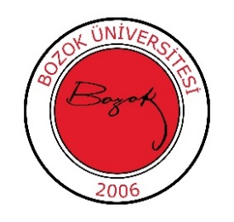 T.C.

YOZGAT BOZOK UNIVERSITY

Faculty of Arts and Sciences

Department of Archaeology

2024-2025 Academic Year Spring Semester

Excuse Exam Schedule

|  |  |  |  |  |
| --- | --- | --- | --- | --- |
| **Course Code and Name** | **Exam Date** | **Exam Time** | **Classroom** | **Responsible Instructor** |
| TDI002 Turkish Language II | 28.05.2025 Wednesday | 10:00 - 11:35 |  | Lect. Mehmet Ali KİRAZ |
| YDL002 Foreign Language II (English) | Lect. M. Cihat BASATOĞRUL |
| ATA002 Atatürk's Principles and History of Revolution II | Lect. Döndü Sena GÖNDÜRÜ, PhD |
| ADSL-013 Mythology and Iconography in Ancient Near Eastern-1 | 28.05.2025 Wednesday | 13:00 - 13:45 |  | Assoc. Prof. Serkan ERDOĞAN |
| KAR001 Career Planning | 26.05.2025  Monday | 11:00 | B-102 | Asst. Prof. Savaş ALTUN |
| ARK122 History of Near Eastern Culture I | 26.05.2025  Monday | 13:00 | B-102 | Asst. Prof. Savaş ALTUN |
| ARK125 Mythology | 27.05.2025 Tuesday | 10:00 | B-102 | Assoc. Prof. Hacer SANCAKTAR |
| ARK124 Archaic Sculpture | 27.05.2025 Tuesday | 13:00 | B-102 | Asst. Prof. Özge ALTUN |
| ARK123 Introduction to Pottery | 28.05.2025 Wednesday | 10:00 | B-102 | Asst. Prof. Özge ALTUN |
| ARK121 Prehistory of Türkiye | 29.05.2025 Thursday | 13:00 | B-102 | Assoc. Prof. Serkan ERDOĞAN |